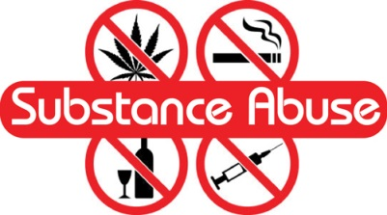

Substance Awareness Education Project
You are a Grade 7 teacher and it is your job to present the class information on the dangers of drug use that will face your students as they enter high school. Your job is to create and present the class information on the drug of your choice. You may also choose alcohol or smoking for your presentation. You can choose the format that you would like to use from the choices below to share this valuable information. Every format must include a quiz and answer sheet to test the learners understanding of the information you have taught them. The type of test is up to you (eg: essay, T/F, multiple choice, fill in the blank). Make sure that your written submission is well written! Have fun and be creative!
Learning Intention:
- Describes healthy alternatives to substance misuse
- Analyzes factors that influences personal health decisions
- Strategies for managing risks related to substances and potentially addictive behaviours (Grade 6 Health Learning Outcome)
- Describe and assess strategies for managing problems related to mental well-being and substance use (Grade 7 Health Learning Outcome)
- Exchange ideas and viewpoints to build shared understanding and extend thinking (Grade 6 Language Arts Learning Outcome)
- Recognize an increasing range of text structures and how they contribute to meaning (Grade 7 Language Arts Learning Outcome)

If you chose to create a…. | Then you must include….
Movie, puppet show, radio broadcast | A script
Website | 4 pages
Poster, brochure, hand-out | Pictures, clear heading and written info
Game | Instructions and did you know cards
Power point | Video clip, images, definitions
Teach a lesson | Handout on your information
Other great ideas you have! | See me with your ideas before you start

Name(s): _________________________________
Substance: _______________________________

Well written---includes many details. There are few spelling or grammar mistakes and there is a logical order to the subtopics that you present. You have covered the information that you included on your follow-up quiz and the information is clear and well organized.

Drug Awareness Education Project Marking Guide
The project effectively informs other students of the dangers and risks associated with the drug and strategies to avoid
The project includes a test and answer key that would adequately test students understanding of the facts taught
The audience was interested and engaged in the format selected to convey the information
Risks, side effects, dangers and symptoms associated with the drug are included in the project
Visuals selected support the topic and increase students understanding

/30
Useful Links
http://www.bibme.org/apa
http://kidshealth.org/teen/drug_alcohol/
http://www.teenchallenge.ca/get-help/educational-resources/drug-abuse-facts
http://www.teenchallenge.ca/get-help/educational-resources/alcohol-abuse-facts
http://www.scholastic.com/drugs-and-your-body/index.htm

