Name: __________________
Parent Signature:
Teacher Signature:
Ethic’s Approval Required? Yes / No
Foothills Science Fair 2016

You cannot start your experiment until you have completed your question and hypothesis and have received your parent’s and teacher’s signed approval.
Question:
What do you want to find out?
My question is:

Hypothesis:
My prediction of what will happen. You can have more than one.
Use the words: “If ____ (I do this)_____, then ____ (this will happen) because _____________.”
My hypothesis is:

Materials:
List everything you will need for your experiment. Be DETAILED! Use point form for this. List specific amounts, brands, etc.
My materials:
- -
- -
- -

Procedure:
These are the steps that you will follow. They must be detailed and repeatable for anyone to EXACTLY follow.
1.
2.
3.
4.
5.
6.
7.
8.
9.
10.

Controlled Variables:
The thing or things that DO NOT change. Sentence form.

Manipulated Variables:
The thing or things that DO change. Sentence form.

Responding Variables:
The thing or things that are affected are. What happened? Sentence form.

Observations:
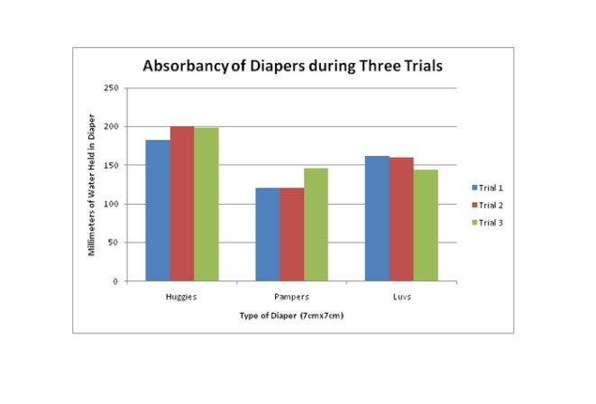
The observations are shown on a table, graph, or chart. These are the evidence of your experiment. Create this using http://nces.ed.gov/nceskids/createagraph/
For example:
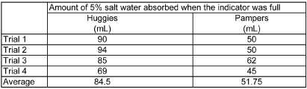

Diagram:
These are visuals of the experiment in action. It can show multiple steps, and needs to be labeled. Photographs, drawings, and videos are examples of using the diagram portion of the lab.
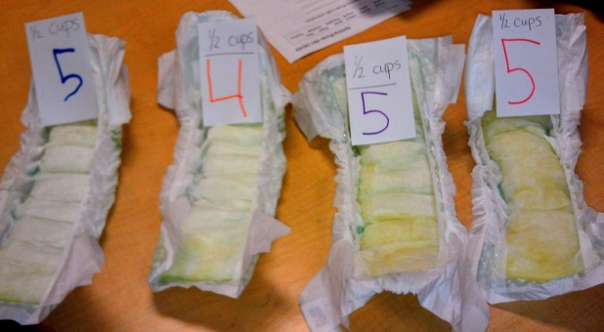
For example:

Analysis:
This is a discussion of the results only. The analysis section comes directly from the graphs and tables. You are telling your results and possible sources of error. For example, on the Penny Lab, you might have had 11 drops, then 30, 33, 35 drops. Obviously, there was a mistake in the first trial. Why? What went wrong? Sentence form.

Conclusions:
This is a summary of the experiment. Was your hypothesis correct? What did you accomplish? What could have you done differently? What are your final thoughts on how it went overall? What is something you or someone repeating a similar experiment could change or do differently?

