Name: ______________________________

Food Diary Analysis
Examine what you have eaten for the past three days.
List 3 good things that you notice about your diet:
1 –
2 –
3 –
List 3 things that are not good about your diet:
1 –
2 –
3 -
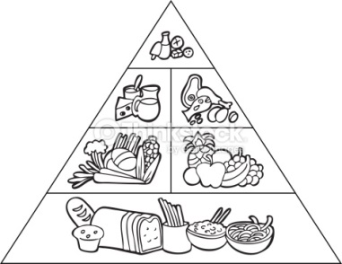
List 3 things you could do to improve your diet:
1 –
2 –
3 –

On average, do you think you get enough exercise? If yes, explain why. If no, explain what you could do to get more.

Overall, my lifestyle is healthy/unhealthy? Circle one.

