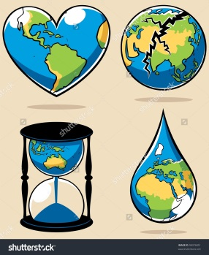
Name: ______________________________
Extreme Environment Project
- Choose an extreme environment from the following list:
caves deserts deep seas extreme cold
- Give a specific place in that extreme environment:
______________________________________________________________________________________
- Find out the following for your extreme environment:
- Where is your extreme environment on the globe? Include a world map that shows where your extreme environment is.
- Why is it considered an extreme environment (lack of light, lack of oxygen, extreme pressure, extreme radiation, etc.)?
- What are the obstacles that may stop or slow down exploration of your extreme environment?
- What are some of the technologies that are used to explore your extreme environment (tools, instruments, etc.)? Explain two of them.
- What are some plants and animals that survive in your extreme environment? List five of each.
- From your list of plants and animals, choose one and do the following:
- Print out a picture of your plant or animal.
- Explain how your plant or animal is able to get the space, food, water, and other resources it needs in your extreme environment.
- Describe how big an area your plant or animal needs in your extreme environment.
- Explain what adaptations your plant or animal has that help them survive in your extreme environment.
- How do you want to show your understanding?
  - Diorama
  - Tri-fold board
  - Power point
  - Model
  - Your idea __________________________________

Learning outcomes:
- Extreme environments exist on Earth
- Natural selection through adaptive radiation
- Survival needs and interactions between organisms and the environment

